Autism Friendly Migration Museum
SOCIAL SCRIPTS FOR FAMILIES
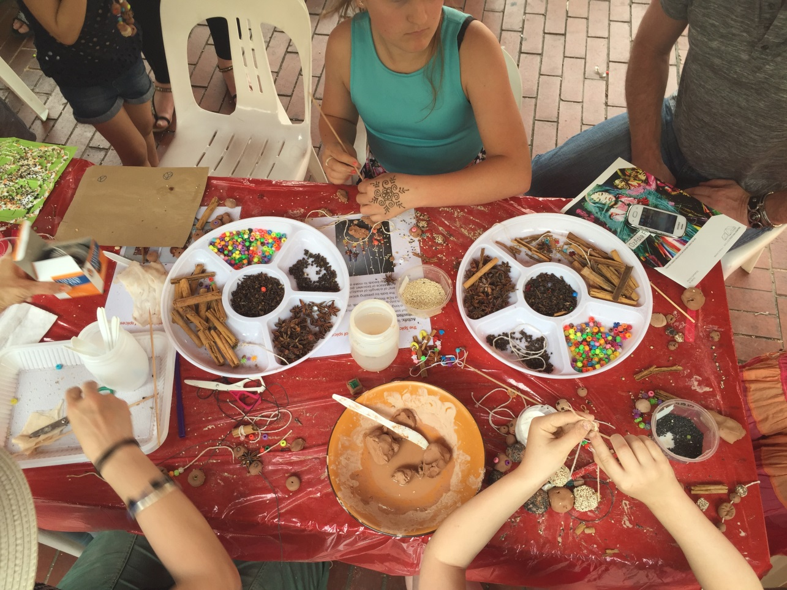
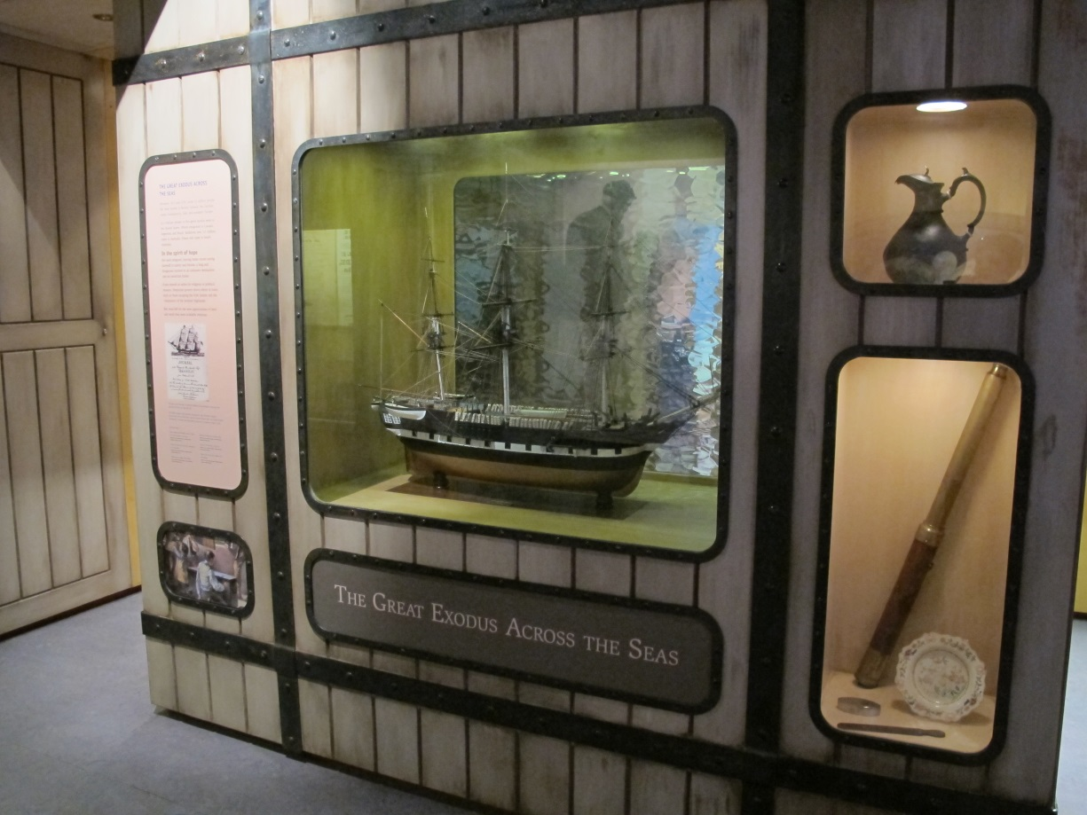
What is the Migration Museum?
The Migration Museum has lots of things on display that belonged to people in the past. I might see toys, clothes, books, maps, or models at the museum. These things, as well as images and sounds, explain our South Australian history. I can look, listen and learn at the museum. I will spend about an hour at the museum.

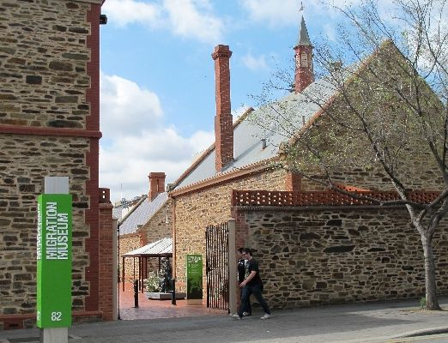
Getting to the museum
When I visit the museum I may get there by car, bus, tram or train. I will look for the green sign on Kintore Avenue and the big brick wall opposite the Anzac Memorial Walk.
If I come by car, we might park in one of the parking spots by the river, or in a carpark in the city. If I come by train we will arrive in the city at the Railway Station and walk along North Terrace to the Museum. Bus and tram stops are nearby on King William Street and North Terrace. When we arrive at the museum we will walk through the big gates and cross the courtyard to get to the entrance of the museum.
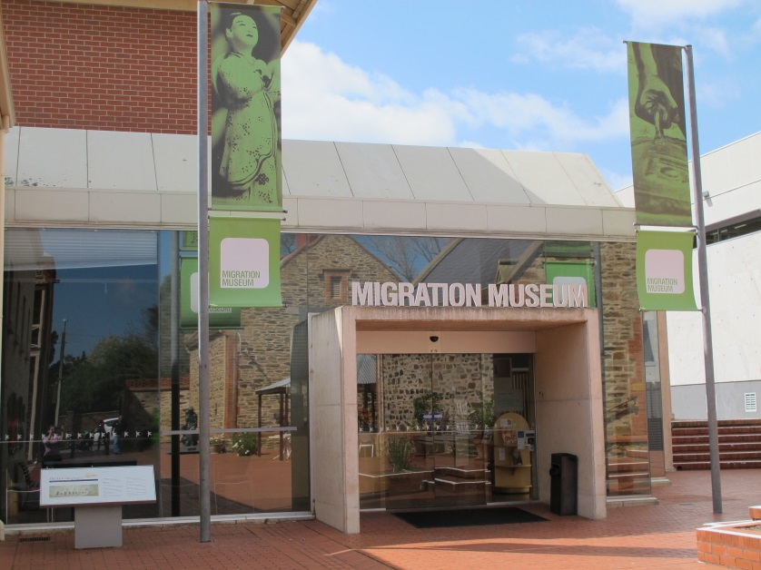
Going into the museum
I know I have arrived at the entrance to the museum when I see the glass sliding doors and green banners above the doorway. There is a sign that says Migration Museum.
I will walk into the foyer of the museum through the sliding glass doors and I will be in a bright space with some display cases. I can look in these and see interesting things.

I do not need to buy a ticket to get into the Migration Museum. There is a donation box in the foyer if I want to put a coin in.
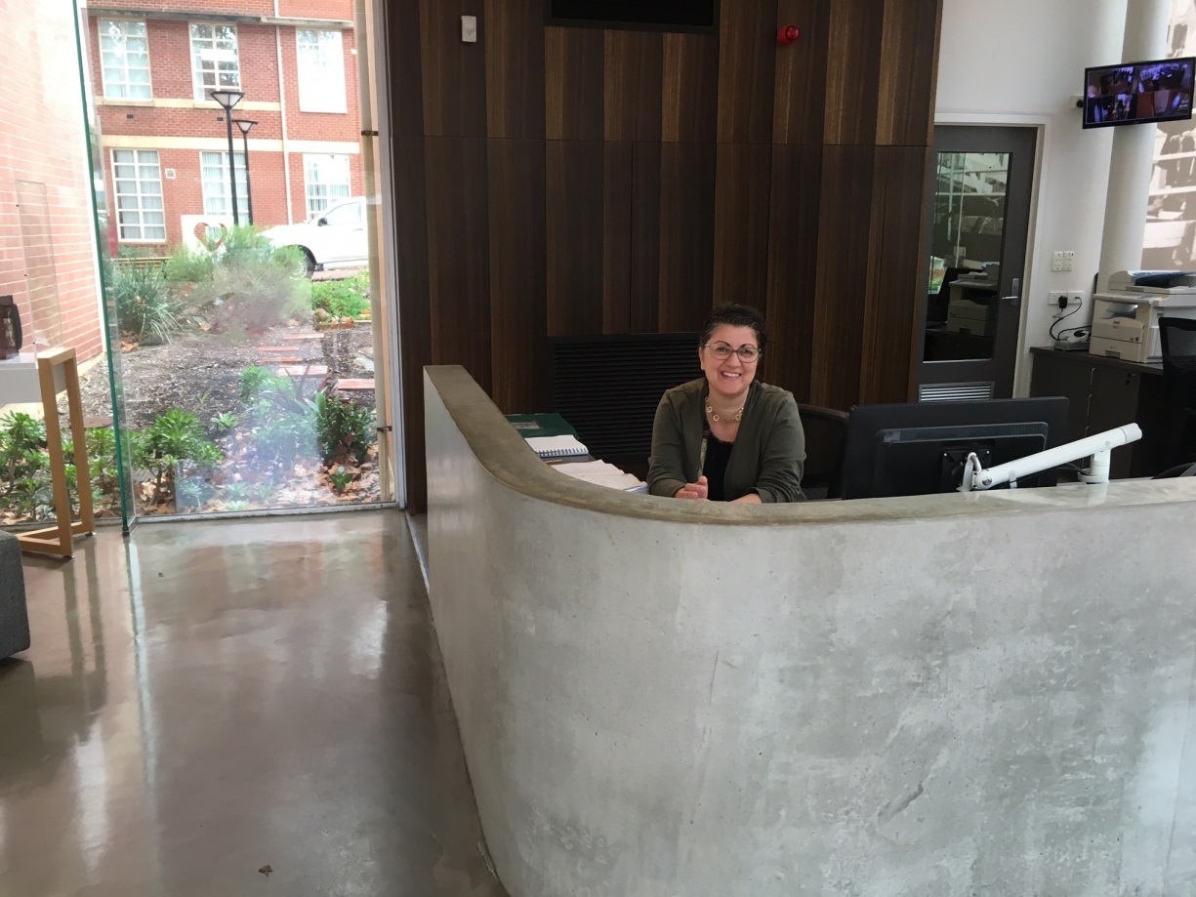
Staff at the museum
Many people visit the museum and many people work there too. If I get lost, a Museum Officer can help me. They wear green badges.

Museum Officers can give me a Detective Trail activity to fill out while I’m visiting the museum, if I want to. I can use pen or pencil for this.

Toilets at the museum
There are bathrooms at the museum in the courtyard. There might be other people in the bathroom too. When I am finished using the toilet, I will wash my hands.
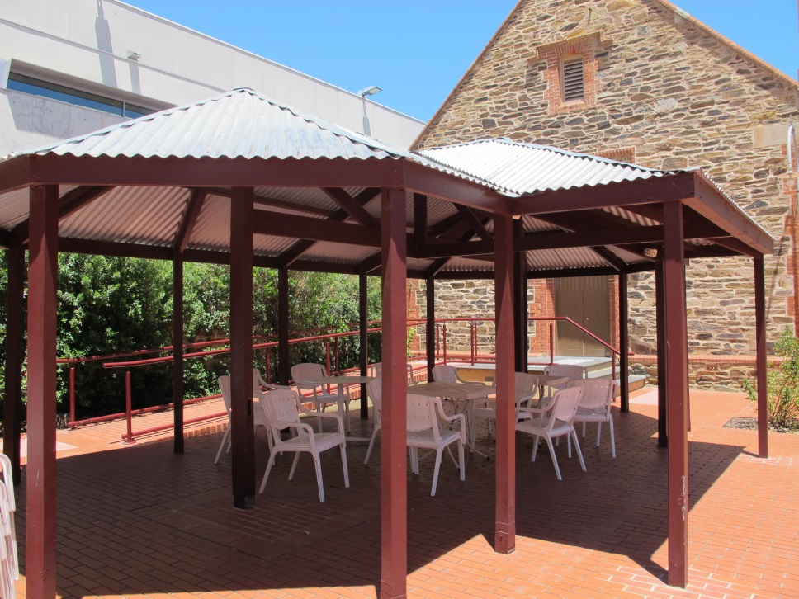
Food and eating at the museum
When I want to eat, I can go to sit outside under the gazebo. I do not eat in the exhibition galleries.

There is a drinking fountain in the courtyard that I can use. There are rubbish bins in the courtyard for my rubbish.

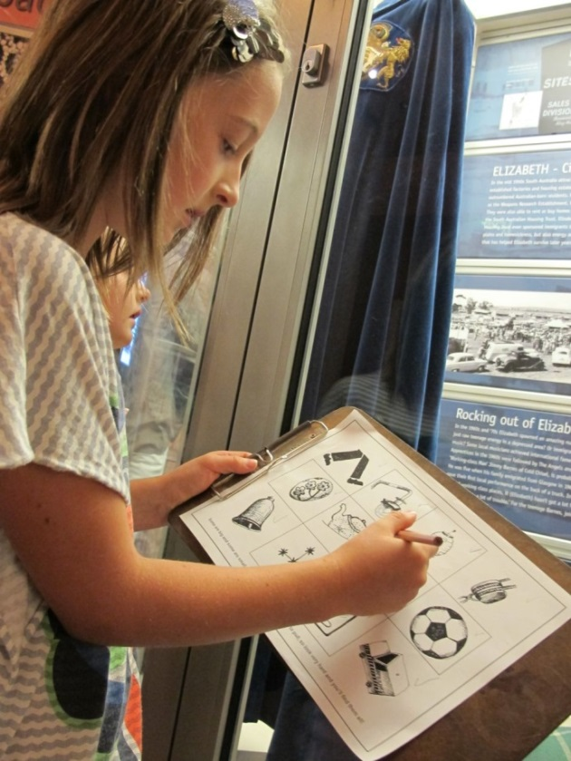
Some important things to remember at the museum
When I explore the Migration Museum I must remember to:
- Stay close to/with my adult
- Walk and not run
- Take turns with other children
- Wait patiently when I have to line up
- Only touch objects I am told that I am allowed to
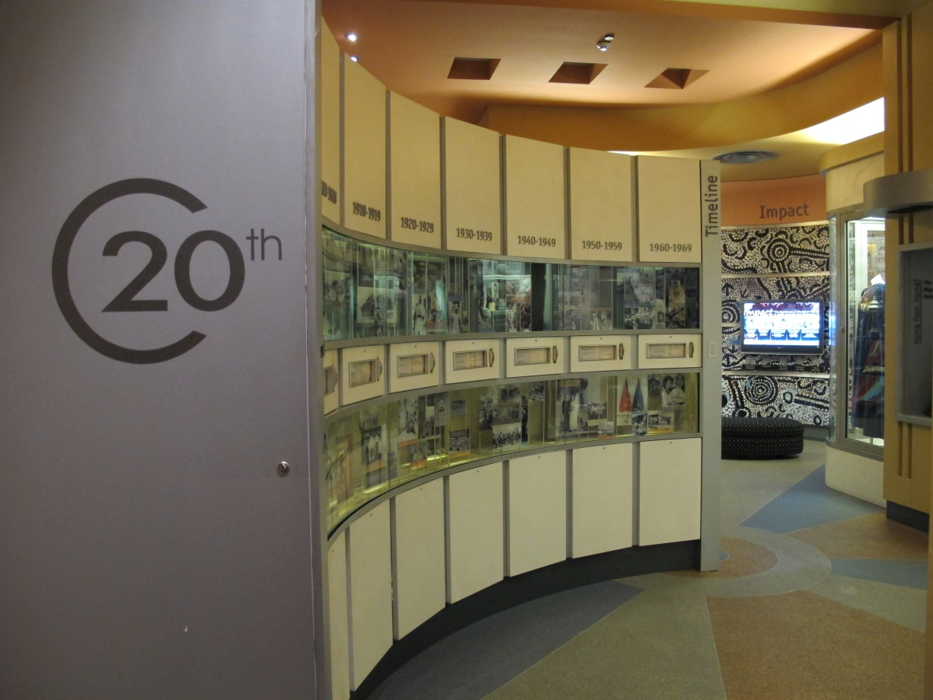
Getting around the museum
When I visit the museum I will look at many different things. Some areas of the museum I will enjoy more than others and that is okay.
Some of the floors have carpet, some have wooden or plastic floor, and these can be noisy to walk on. There are some steps and ramps to the buildings.

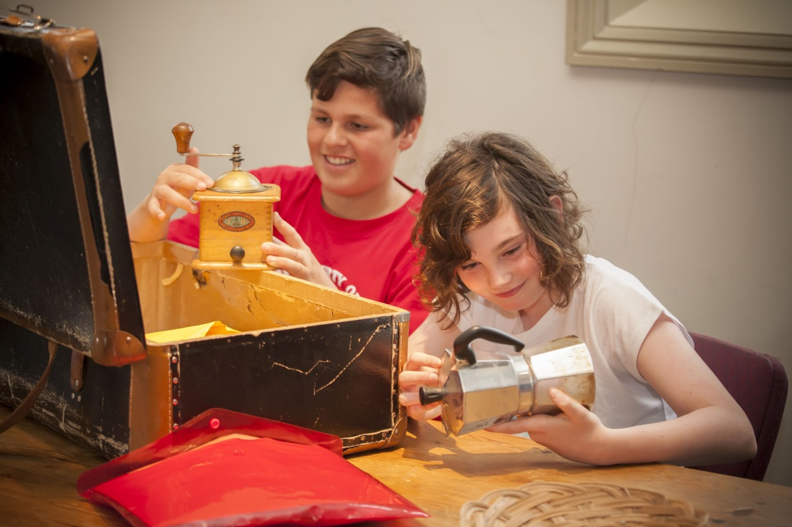
What can I touch?
At the museum there will be lots of interesting things. I am allowed to touch some of these things. There are other things that I cannot touch. I will just look at these things. I will be told which ones I can touch and which ones to just look at. If I am not sure whether I can touch something I will ask an adult.

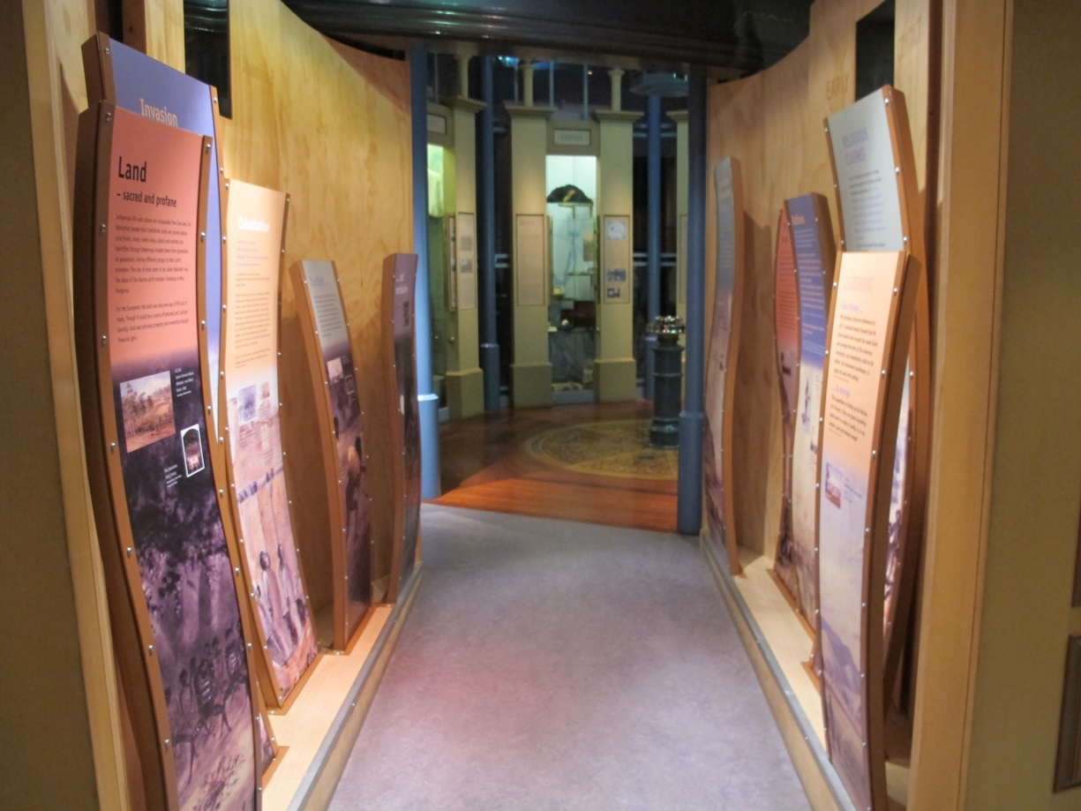
Small spaces
The museum is a special building and inside it looks and feels different to home or school. Some rooms at the museum are big, some are small. Some rooms at the museum might be dark or bright. If I don’t like being in a room and feel uncomfortable I will tell an adult, and there is a quiet room I can go to.

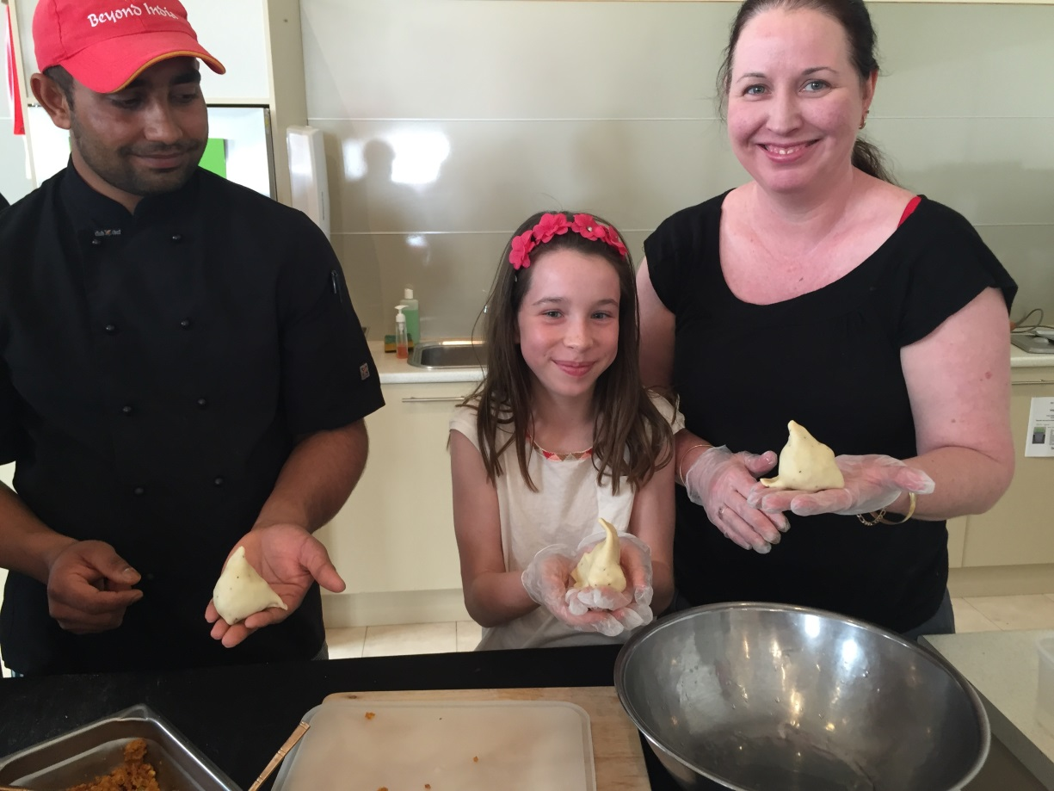
Having fun
My visit to the Migration Museum will be fun!

