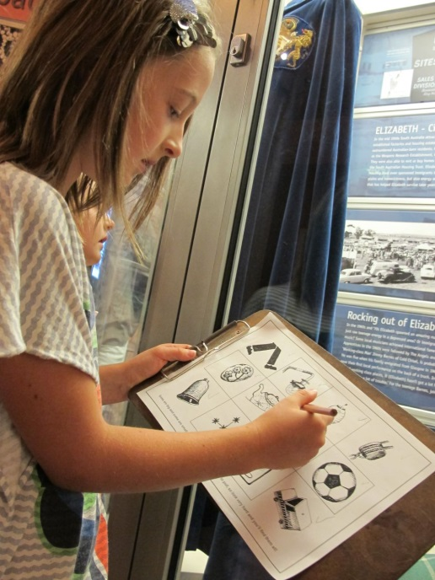
SOCIAL SCRIPTS FOR YOUNGER CHILDREN

My adventure to the Migration Museum

This book belongs to ____________________
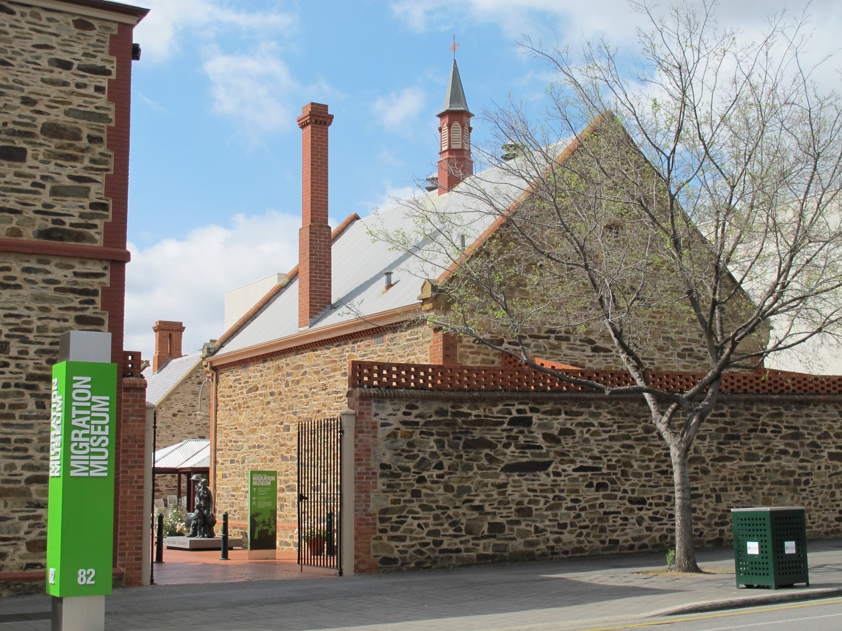
I am going to the Migration Museum.
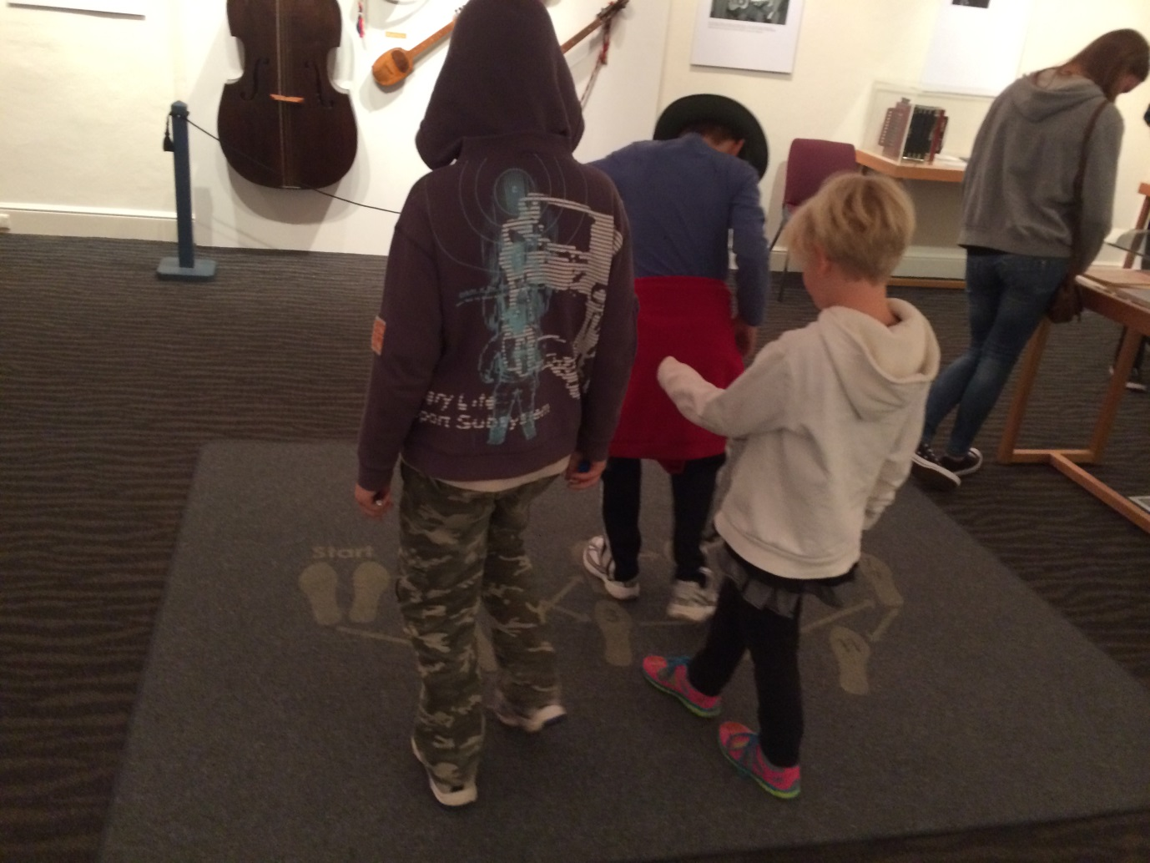
I might go with my family, school, or with friends.

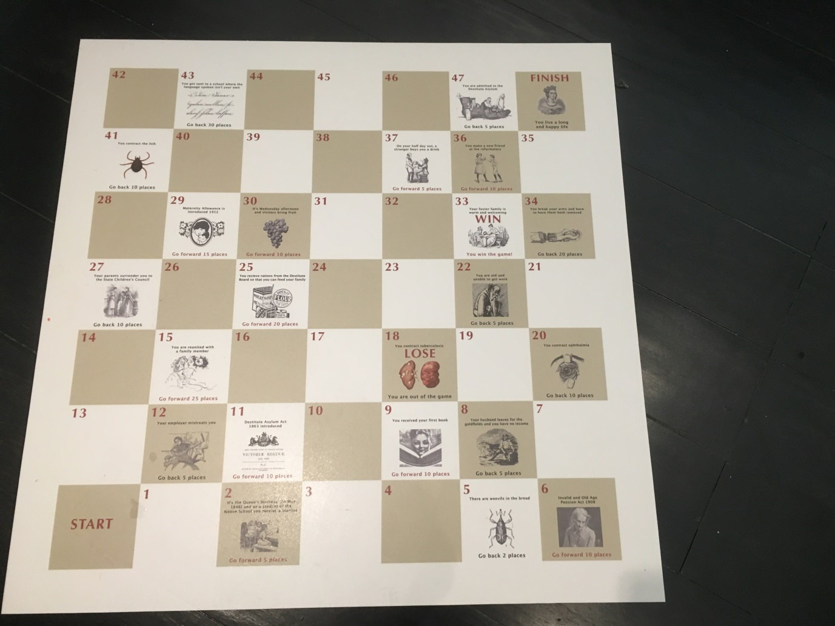
I will see lots of things in the museum, and there are games to play.

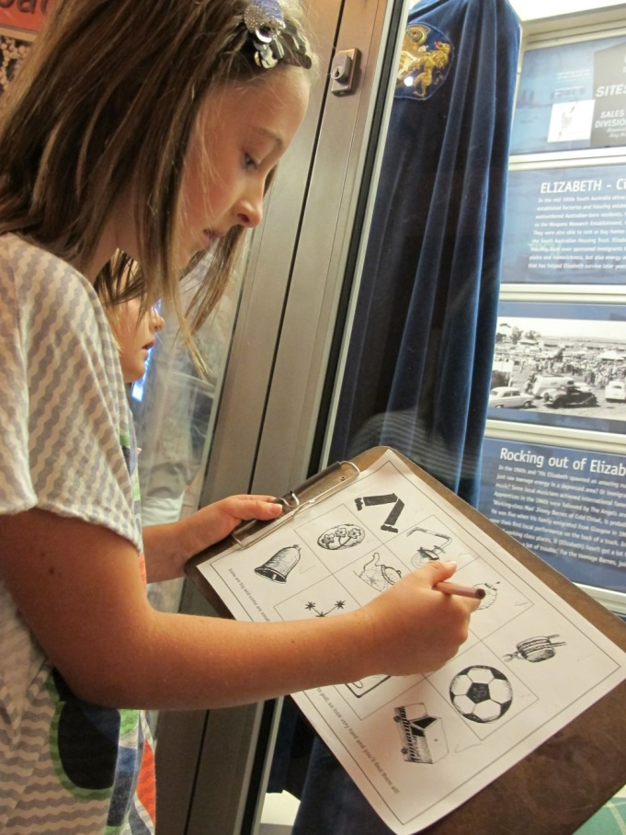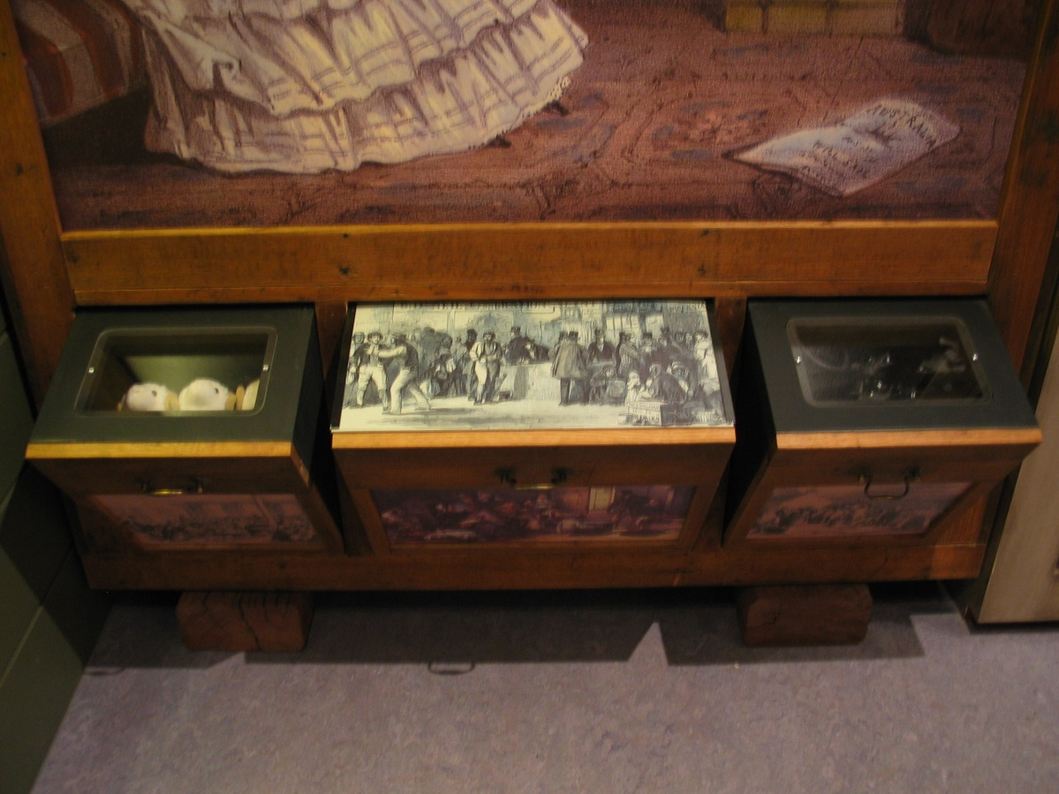
There are quizzes I can do, and drawers I can open to find surprises!

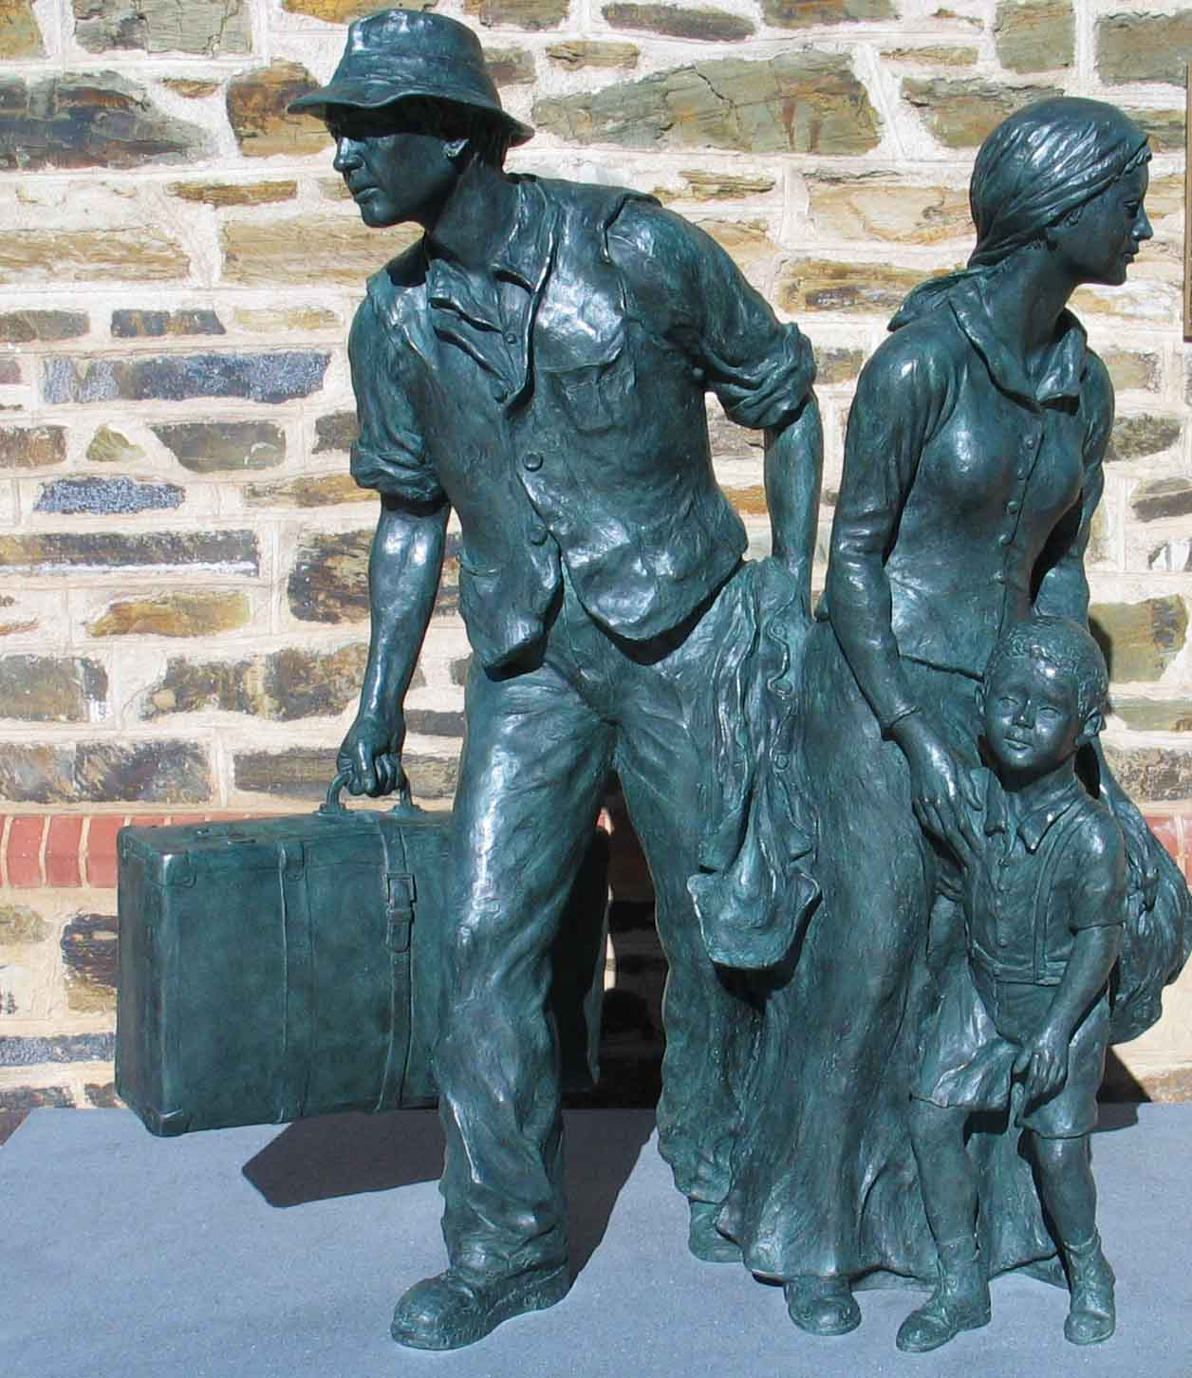
Inside the museum, I must stay with an adult.

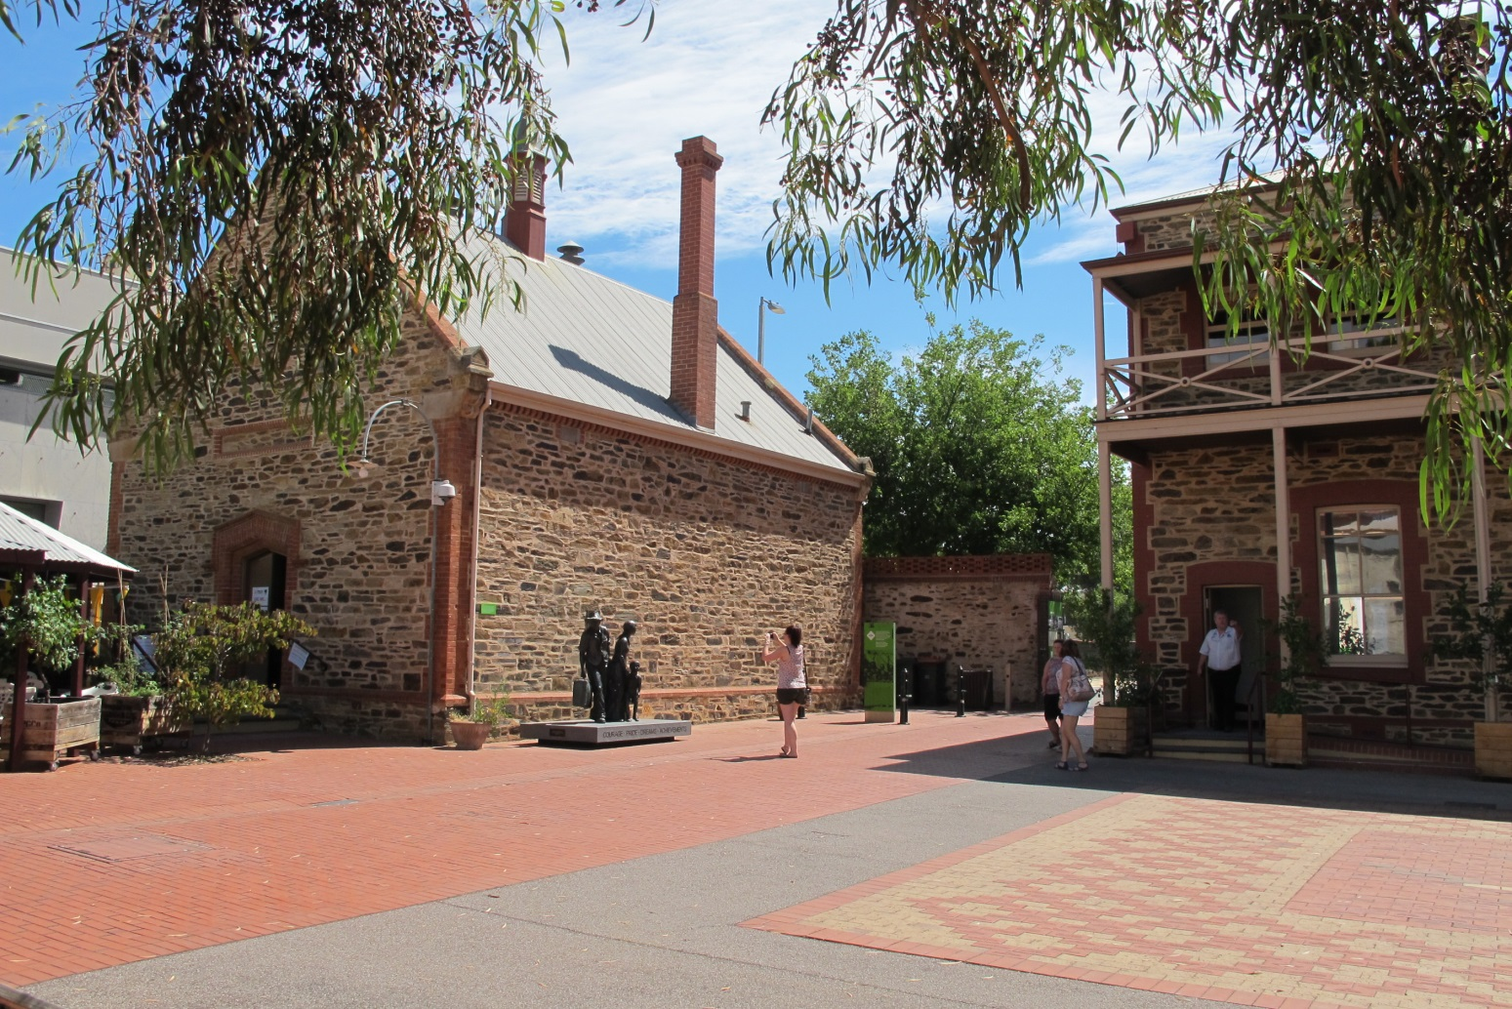
When I want to eat, I can go to the courtyard. I do not eat inside the museum.
If I need to run around, my adult can take me outside into the courtyard.
If I need some quiet time there is a quiet zone I can go to.
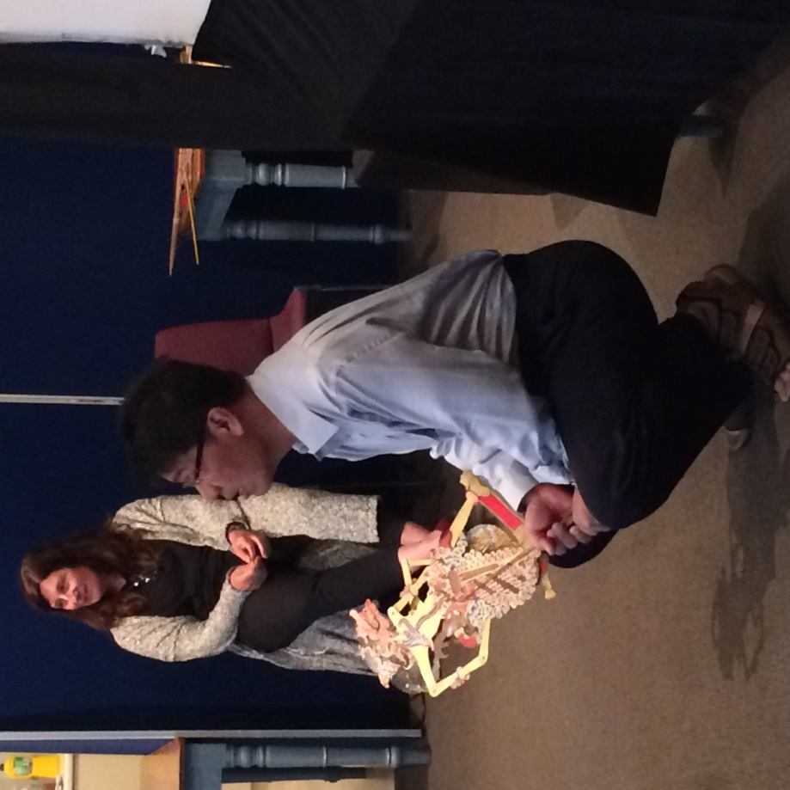
Some things I can touch. Some things I can’t touch.
I will ask an adult which things I can and can’t touch if I am not sure.

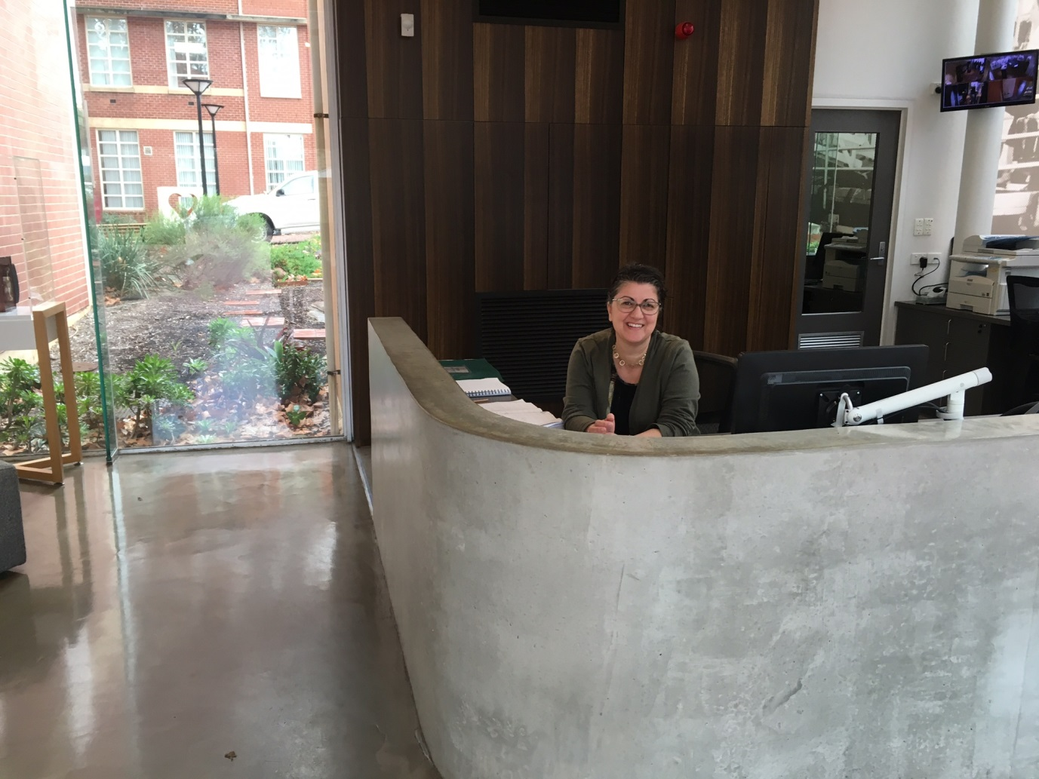
If I get lost I can ask a museum staff member for help.
Staff wear green badges.
Going to the museum will be fun.

